Introduction
Purpose Statement
The purpose of this community health needs assessment (CHNA) is to identify the most pressing health needs of area serviced by Mt Graham Regional Medical Center (MGRMC). This CHNA report meets requirements of the Patient Protection and Affordable Care Act that not-for-profit hospitals conduct a community health needs assessment at least once every three years.
This is the third cycle for MGRMC with our first CHNA conducted in 2013.
This CHNA report was adopted by the MGRMC board on 11-12-2019.
This report is widely available to the public on the hospital’s website www.mtgraham.org, and a paper copy is available for inspection upon request by emailing ryanr@mtgraham.org.
Written comments on this report can be submitted by email to ryanr@mtgraham.org.

About Mt Graham Regional Medical Center
Mt Graham Regional Medical Center is a 49 bed licensed hospital located in Safford, Arizona, in the county of Graham. MGRMC is a community owned hospital that opened in December 1973.
MGRMC is continually striving to offer the highest quality healthcare through a wide range of services that include: Primary Care, Surgery (General, Orthopedic, OB/GYN, Gastroenterology, Podiatry and Specialty), Imaging (X-ray, CT Scan, MRI, Mammography, Ultrasound, Bone Density, Nuclear Medicine, PET Scan), Emergency, Maternity, Intensive Care, Laboratory, Sleep, Oncology/Chemotherapy, Physical Therapy, Speech/Occupational Therapy, Diabetes Education/Nutrition Counseling.
MGRMC has a staff of over 500 employees with a full-time staff that exceeds 340 individuals. Annually, MGRMC provides care to approximately 1,250 inpatients and sees over 21,000 patients come through our emergency department. MGRMC averages approximately 600 births annually as well.
The primary service area of MGRMC is the entirety of Graham and Greenlee Counties in Arizona excluding those areas in Graham County that fall within the borders of the San Carlos Indian Reservation. MGRMC welcomes patients from the reservation, but the primary service area of the San Carlos Hospital includes the entire reservation, including the community of Bylas—a reservation community located along the western border of Graham County.
To help meet the needs of uninsured and underinsured community members, MGRMC provides financial assistance and payment arrangements when possible. In 2018, MGRMC provided $616,938 in charity care and wrote off $5,090,226 to bad debt.

Community Profile

Definition of Community
MGRMC is located in Safford, Arizona, an agricultural and mining community located in Graham County in the southeastern corner of the state. According to the American Community Survey (ACS), the population of Graham County is 37,700 while the population of neighboring Greenlee County stands at 9,368. The total population for MGRMC’s service area (which is a combination of Graham and Greenlee counties excluding those living on the San Carlos Reservation) is estimated at 42,954.
Among those living in MGRMC’s Primary Service Area (PSA), approximately 56% are Caucasian, 39% are Hispanic, and smaller percentages are African American, Asian/Pacific Islander, Native American and other racial descent (ACS).
According to the County Health Rankings and Roadmaps, Graham County ranks 9th out of 15 counties in Arizona for health outcomes, with 15 being the unhealthiest. Greenlee county ranks 2nd out of 15. In the map below, the rankings of each county’s health outcomes are represented by contrasting colors. The lighter the color, the healthier the outcomes for that county. While Graham County is performing near the middle, there is an opportunity for healthier outcomes among the citizenry. Greenlee County is performing well above average.
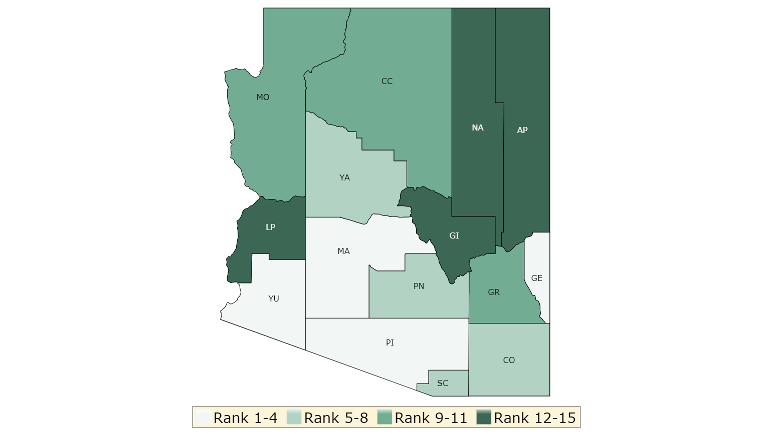

When it comes to health factors such as health behaviors, social and economic factors, and the physical environment, Graham County again ranks 9th out of 15 counties and Greenlee County again ranks 2nd.
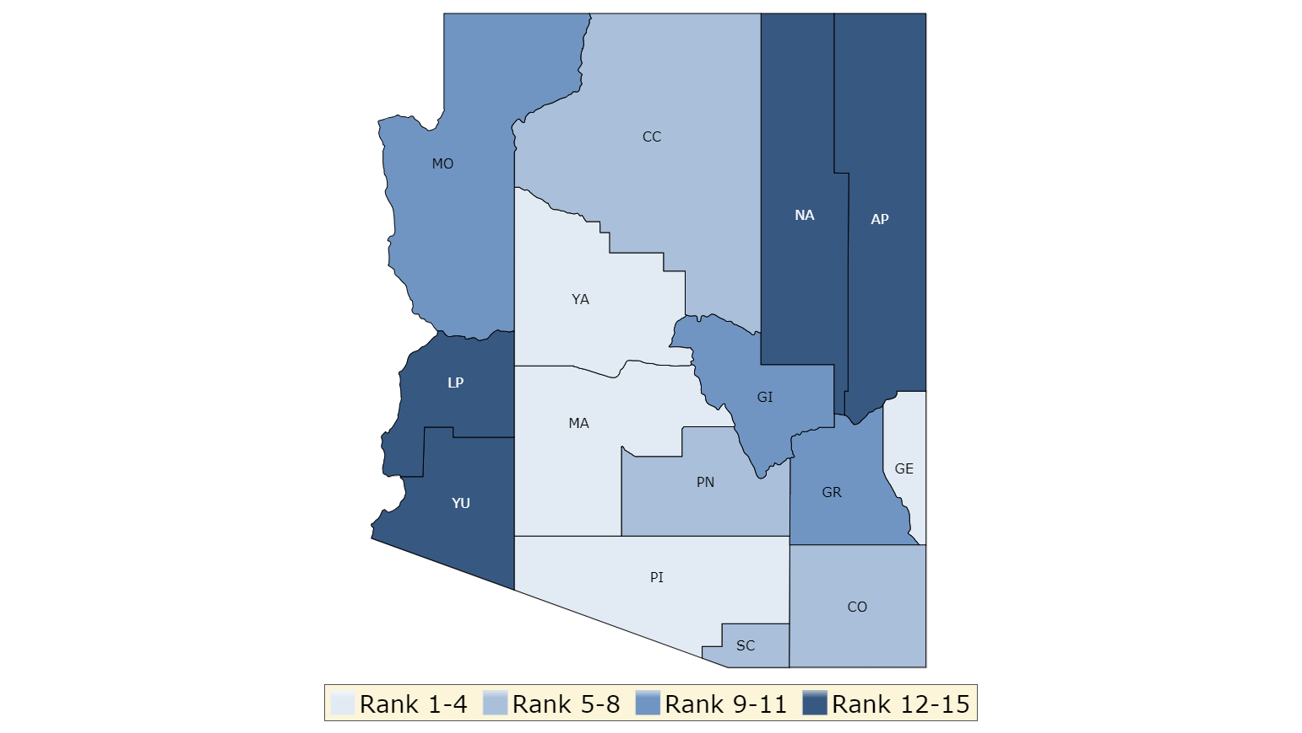

Community Demographics

 | Graham County | Greenlee County | Arizona
2017 Population | 37,700 | 9,386 | 6,967,758
Gender
- Male | 53.7% | 53.3% | 49.70%
- Female | 46.3% | 46.7% | 50.3%
Age
- 0-14 | 22.7% | 23.10% | 19.7%
- 15-19 | 7.5% | 7.9% | 6.8%
- 20-24 | 7.7% | 6.7% | 7.1%
- 25-34 | 15.1% | 14.4% | 13.3%
- 35-54 | 23.7% | 24.4% | 24.6%
- 55-64 | 10.2% | 11.6% | 11.9%
- 65+ | 12.8% | 11.8% | 16.6%
- Median Age | 33.1 | 33.4 | 38.7
Ethnicity
- White Non-Hispanic | 51.2% | 47.6% | 55.0%
- Black Non-Hispanic | 1.8% | 2.0% | 4.2%
- Hispanic | 32.5% | 46.4% | 31.1%
- Asian & Pacific Islander Non-Hispanic | 0.9% | 0.4% | 3.4%
- All Others | 13.6% | 3.6% | 6.3%
Educational Attainment
- Less Than High School | 4.6% | 3.7% | 4.2%
- Some High School | 11.2% | 8.4% | 5.1%
- High School Degree | 31.0% | 37.5% | 16.2%
- Some College or Associate's Degree | 41.1% | 40.0% | 22.7%
- Bachelor's Degree or higher | 12.1% | 10.4% | 18.1%
Social % Economic Factors
- Average Household Income | $ 56,591 | $ 69,915 | $ 72,422
- Median Household Income | $ 48,173 | $ 56,298 | $ 60,385
- Median House Value | $ 123,500 | $ 87,500 | $ 209,016
Employment Status
- Employed | 43.5% | 52.40% | 54%
- Unemployed | 12.2% | 7.6% | 5.3%
- Not In Labor Market | 50.50% | 43.30% | 40.3%
Poverty Level
- All Families | 21.4% | 11.5% | 17.0%
- Children | 28.7% | 15.7% | 24.0%

- Graham and Greenlee Counties have a lower median age and a significantly lower senior population in comparison with the Arizona state average.
- Greenlee County has a significantly higher Hispanic population versus the Arizona average while Graham County’s Hispanic population is within two percentage points of the state average.
- The number of individuals with a high school diploma and some college experience in Graham and Greenlee Counties are significantly higher than the state average. However, the number of individuals with a bachelor’s degree or higher falls below the state average. Graham County is home to Eastern Arizona College, a community owned two-year educational institution. While some bachelor degree opportunities exist in the area, the closest four-year university to the area is over 125 miles away.
- The median and average household income in both counties is less than the state average. In the case of Graham County, both median and average household income is significantly lower than the state average. House value is also significantly lower than the state average in both counties with median housing values in Greenlee County falling below half of median value statewide.
- Unemployment in both counties is higher than the state average with Graham County’s unemployment rate more than doubling the state average. Both counties’ have a higher population below the poverty level than the statewide average.

Process and Methods Used To Conduct The CHNA
Mt Graham Regional Medical Center CHNA Steering Committee
As part of the process for evaluating community need, a CHNA steering committee was formed. This committee, which was commissioned to guide the CHNA process, was comprised of professionals from a variety of disciplines across the organization and from the community. This steering committee has provided guidance in all aspects of the CHNA process. The Steering Committee members included:
- Mark Marchetti – MGRMC President and CEO
- Ryan Rapier – MGRMC Director of Marketing and Development
- Carolyn McCormies – Eastern Arizona College Director of Nursing
- Brian Douglas – Graham County Department of Health Services Director
- Stacie Hincha – MGRMC Emergency Department Director
- Bryant McNeill – MGRMC Rural Health Clinic Medical Director
- Diane Hansen – MGRMC Director of Clinics
- Amber McCormies – MGRMC Social Worker

Assessment Process

The CHNA process started with an overview of our primary service area. The service area was defined as the market where at least 80 percent of inpatient admissions originated. The steering committee then met to build a survey designed to identify gaps in health services available or gaps in access to health services available in MGRMC’s service area. This survey was administered online and was also made available through physician offices, the county health department and through community outreach sessions conducted by members of the steering committee.

Summary of Findings and Addressing Need:

The CHNA survey conducted by MGRMC had over 300 respondents. Based on the findings of this survey, a summary of findings was comprised for review by the steering committee and MGRMC’s leadership team. The steering committee then identified the following significant healthcare needs and recommended they be addressed in the implementation plan finalized and approved by the MGRMC administrative team and the MGRMC Board of Directors.

- Improved Treatment and Services for Substance Abuse
- Improved Treatment and Services associated with Mental Health
- Improved Services for Diabetes
- Improved Opportunities for Wellness
- Additional Specialty Services Provided Locally

Implementation Plan

For each of the identified issues, the MGRMC Administrative team has prepared a plan for the hospital to address each issue going forward. They are as follows:

Improved Treatment and Services for Substance Abuse

MGRMC has provided and will continue to provide financial support to the Graham County Substance Abuse Coalition in their efforts to combat opioid abuse and response in the Gila Valley. In 2019, the hospital recruited a physician specializing in pain management whose practice is housed in the medical office building located on the hospital’s campus. Hospital policies and practices related to the use and dispensing of narcotics are reviewed regularly for appropriateness and compliance with State regulations. The hospital works to ensure the appropriate referral to substance abuse treatment services and includes coverage for such services in its employee benefits program.

Improved Treatment and Services Associated with Mental Health

MGRMC has been and will continue to investigate the feasibility of improved tele-psych services in the Emergency Department. In 2019, the hospital employed a Master’s prepared social worker to address the psycho-social needs of the hospital’s patients. The hospital’s Employee Assistance Program provides easy access to mental health and related services to hospital employees and their families. The hospital works closely with mental health providers both in the community and in the Phoenix and Tucson metropolitan areas to ensure the appropriate referral of patients for needed care.

Improved Services for Diabetes

In early 2017, the hospital employed a Registered Dietician on a full-time basis to oversee nutrition and diabetes services. Services include individual nutrition counseling, diabetes education, and group support meetings. The dietician works on expanding diabetes knowledge through school visits and community health fairs. The hospital continues to support and participate in the Gila Valley Diabetes Coalition, which exists to increase awareness of and response to diabetes.

Improved Opportunities for Wellness

The hospital’s Copper Mountain Clinic, a federally designated rural health clinic, provides access to primary care services to un-insured and under-insured individuals living in the hospital’s service area. The Clinic is staffed with a full-time physician’s assistant, a full-time nurse practitioner, and a part-time physician internist. Services include wellness visits, immunizations, illness care, health education, etc. The hospital provides a financial incentive to employees for membership in local fitness facilities. The hospital will continue to promote wellness through community health fairs and will work with local clubs, organizations and wellness facilities to promote wellness activities. The hospital and it’s foundation provide support for runs, golf outings, and other sports and wellness related events.

Additional Specialty Services Provided Locally

MGRMC continually strives to support the recruitment of physicians to the Gila Valley, whether on a full-time basis or on a part-time basis to the hospital’s Specialty Clinic. In 2019 the hospital provided recruitment support for an additional pediatrician to join the Gila Valley Clinic. In addition, the hospital has been providing on-going support to a general surgery resident who will begin practice in Safford in the summer of 2020. A physician, fellowship-trained in pain management, began practice in the hospital’s medical office building in August of 2019. Also in 2019, the hospital’s Specialty Clinic added physicians specializing in oncology and added an endocrinologist who sees patients through telemedicine. The hospital’s Board of Directors recently appointed a work group to evaluate options related to cardiology services in the community.

Community Contact Information for CHNA

Community members who would like to provide input on the next CHNA process, would like to comment on the needs identified or would like to review detailed community health statistics and data gathered and reviewed by the committee, are encouraged to contact MGRMC with their inquiries, suggestions or comments.

CHNA Contact for MGRMC:
Ryan Rapier, Director of Marketing and Development
928-348-3748
ryanr@mtgraham.org

